Linux Programming – Working with Files

You’ll learn how to create files, open them, read, write, and close them in the language of C. You’ll also learn how programs can manipulate directories (to create, scan, and delete them, for example).

Before proceeding to the way Linux handles file I/O, we need to review the concepts associated with files, directories, and devices.

Notes on Linux File Structure (directories,files and devices, system calls and device drivers,library functions, low-level file access, other system calls for managing files, the standard I/O library, formatted input and output, other Stream functions, file and directory maintenance, scanning directories, Errors,advanced topics: fcntl and mmap)

As with UNIX, files in the Linux environment are particularly important, because they provide a simple and consistent interface to the operating system services and devices. In Linux, almost everything is a file.

This means that, in general, programs can use disk files, serial ports, printers, and other devices in exactly the same way they would use a file. They allude to exceptions to this with network connections. Mainly we need only five basic functions: open, close, read, write, and ioctl.

Notes on Directories

Directories, too, are a special sorts of files. In modern UNIX versions, including Linux, even superuser may not write to them directly. All users ordinarily use the high-level opendir/readdir interface to read directories without needing to know the system-specific details of directory implementation.

The ioctl system call is used to provide some necessary hardware-specific control (as opposed to regular input and output), so its use varies from device to device. For example, a call to ioctl can be ued to rewind a tape drive or set the flow control characteristics of a serial port. For this reason, ioctl isn’t necessarily portable from machine to machine. In addition, each driver defines its own set of ioctl commands. Man 2 is the documentation.

Notes on Library Functions

There is a performance penalty in making a system call. System calls are therefore expensive compared to function calls because Linux has to switch from running your program code to executing its own kernel code and back again.

It’s a good idea to keep the number of system calls used in a program to a minimum, or get them to do as much work as possible each use. For example writing large amounts of data rather than a single character at a time.

The hardware has limitations that can impose restrictions on the size of data blocks that can be read or written by the low-level system call at any one time. For example, tape drives often have a block size, say 10k, to which they can write. So, if you attempt to write an amount that is not exact multiple of 10k, the drive will advance to the next block, leaving gaps.

Linux provides a higher-level interface to devices and disk files. These standard libraries can handle problems by buffering output, for example. You can effectively write data blocks of varying sizes, and the library functions arrange for the low-level system calls to be provided with full blocks. This dramatically reduces the system call overhead. Library functions are in man 3 for example stdio.h

Write

#include <unistd.h>
size_t write(int fildes, const void *buf, size_t nbytes);

#include <unistd.h>
#include <stdlib.h>

int main(){
if ((write(1, "Here is some data to display\n", 29)) != 29)
write(2, "A write error has occurred on file descriptor 1\n",47);
exit(0);
}

This program simply prints a message to the standard output. When a program exits, all open file descriptors are automatically closed, so you don’t need to close them explicitly. This won’t be the case when you’re dealing with buffered output.

Notes on Read

The read system call reads up to nbytes bytes of data from the file associated with the file descriptor fildes and places them in the data area buf. It returns the number of data bytes actually read, which may be less than the number requested. If a read call returns 0, it had nothing to read; it reached the end of the file. A error will cause a return of -1.

#include <unistd.h>
size_t read(int fildes, void *buf, size_t nbytes);

#include <unistd.h>
#include <stdlib.h>

int main()
{
char buffer[128];
int nread;
nread = read(0, buffer, 128);
if (nread == -1)
write(2, "A read error has occurred\n", 26);
if ((write(1, buffer, nread)) != nread)
write(2, "A write error has occurred\n", 27);
exit(0);
}

This program, simple_read.c copies the first 128 bytes of the standard input to the standard output. It copies all of the input if there are fewer than 128 bytes.

Using pipes: echo hello there | ./simple_read
hello there
piping in a file: ./simple_read < draft.txt

Notes on Open

To create a new file descriptor, you need to use the open system call.

#include <fcntl.h>
#include <sys/types.h>
#include <sys/stat.h>
int open(const char *path, int oflags);
int open(const char *path, int oflags, mode_t mode);

Strictly speaking, you don’t need to include sys/types.h and sys/stat.h to use open on systems that comply with POSIX standards, but they may be necessary on some UNIX systems.

In simple terms, open establishes an access path to a file or device. If successful, it returns a file descriptor that can be used in read, write, and other system calls. The file descriptor is unique and isn’t shared by any other processes that may be running. If two programs have a file open at the same time, they maintain distinct file descriptors. If they both write to the file, they will continue to write where they left off. Their data isn’t interleaved, but one will overwrite the other. Each descriptor tracks its own offset. You can prevent this by file locking. See chapter 7

The name of the file or device to be opened is passed as a parameter, path; the oflags parameter is used to specify actions to be taken on opening the file.

The oflags are specified as a combination of a mandatory file access mode and other optional modes. The open call must specify one of the file access modes.
O_RDONLY Open for read-only
O_WRONLY Open for write-only
O_RDWR Open for reading and writing

The call may also include a combination (using bitwise OR) of the following optional modes in oflags parameter:
O_APPEND: place written data at the end of the file
O_TRUNC: Set the length of the file to zero, discarding existing contents.
O_CREAT: creates the file, if necessary, with permissions given in mode.
O_EXCL: Used with O_CREAT, ensures that the caller creates the file. The open is atomoc; that is, it’s performed with just one function call. This protects against two programs creating the file at the same time. If the file already exists, open will fail.

Other possible values for oflags are documented in man 2 open

open returns the new file descriptor (always a nonnegative integer) if successful, or -1 if it fails, at which time open also sets the global variable errno to indicate the reason for the failure.

There are a number of files that any one running program may have open at once is limited. The limit, usually defined by the constant OPEN_MAX in limits.h, varies from system to system.

Let’s search for limits.h to see what OPEN_MAX says:
Debian and CentOS
usr/include/limits.h references bits/xopen_lim.h. Let’s search that.
usr/include/x86_64-linux-gnu/bits/xopen_lim.h
Here OPEN_MAX has no limits.

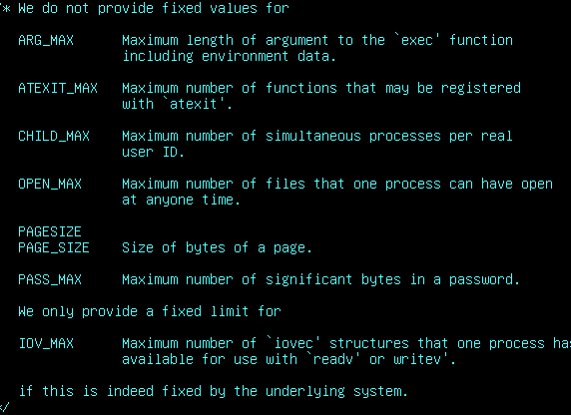

FreeBSD limits.h There are limits to how many are open.
